Check Programs
The program requires
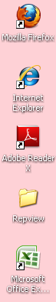

1. Set the macro security
-open Excel 2010 Programs
-File Options
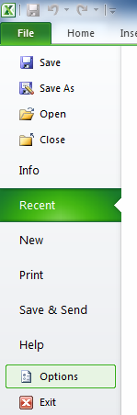

[1-2]Click ‘Trust Center’ and Click button ‘Trust Center Settings…’
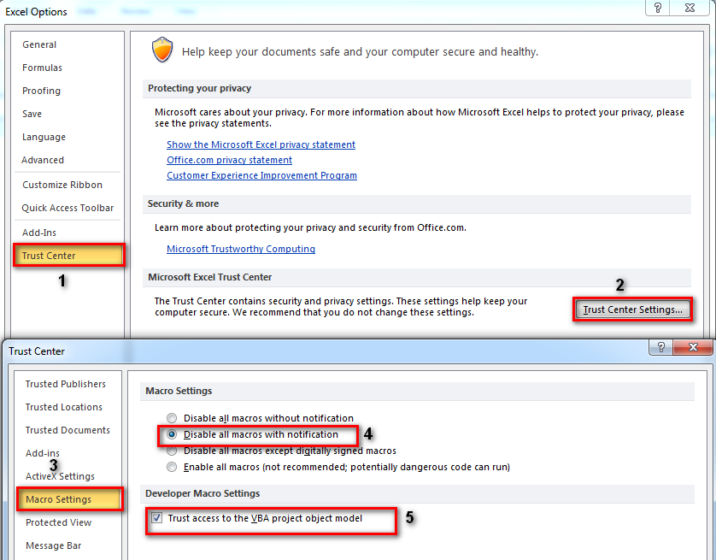
[3-5]-Click tab‘Macro Settings’ choose ‘Disable all macros with notification’ and check ‘Trust access to the VBA project object model’
[6-9]-To turn off Protected View on the desktop to prevent this message appearing ‘uncheck’ the following Excel option:
-Click tap’ Protected View’ and Uncheck ‘Enable Protected View for files located in potentially unsafe locations’ and click OK OK again
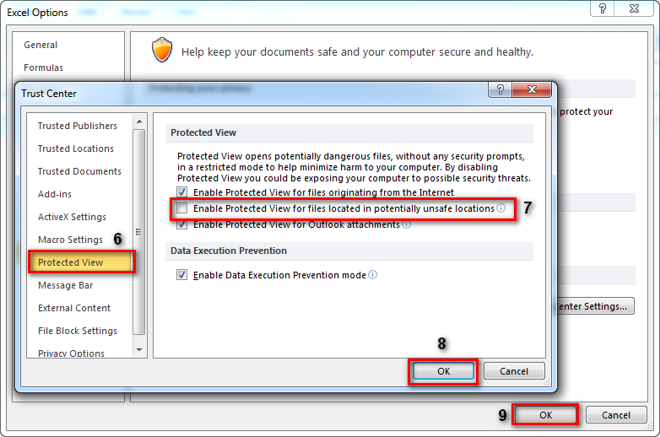

2. Setup the following step.
[1-3]-Open IE [internet Explorer] Select ‘Tool -> ‘internet Options’ -> ‘Security ‘Select a Zone ‘Internet’ -> ‘Custom level…’ (Button)
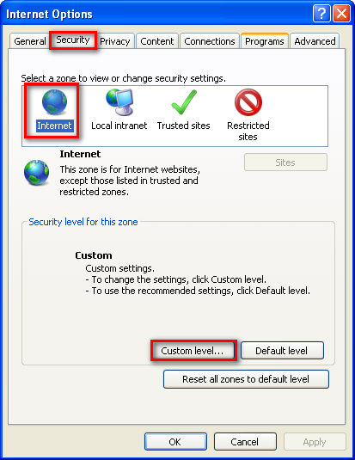
-Go to ‘initialize and script ActiveX controls not marked as safe for….’ Select ‘Prompt’
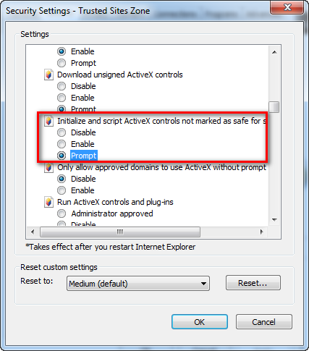

-Go to ‘Downloads’ Select ‘Enable ’ All
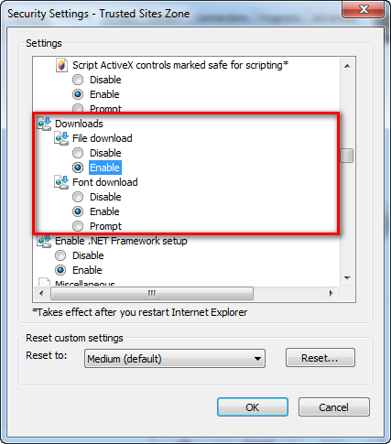

-Go to ‘Allow status bar updates via script’ Select ‘Enable’

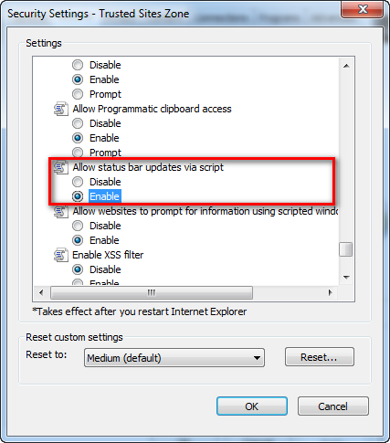

3. Test Run IE/Fire Fox
-Open Browser Page Login
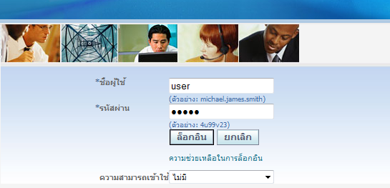
-Go to Homepage Manu ->’General Ledger71’->รายการบันทึก -> เริ่มใช้วิซาร์ต Journal
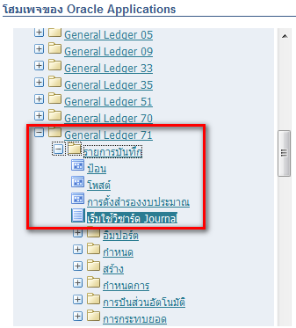
-Check โปรแกรม= excel??
- โครงร่าง= สกุลเงินอื่นตามจริง-รายการเดียว
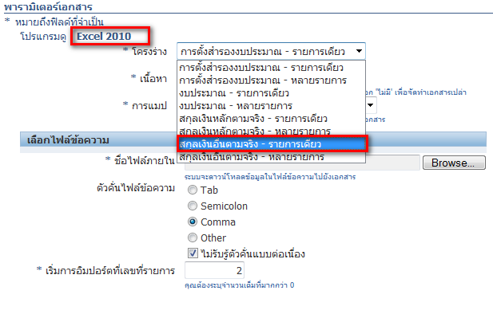
-เนื้อหา=ไม่มี
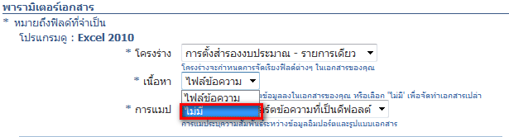

-Click ‘จัดทำเอกสาร’
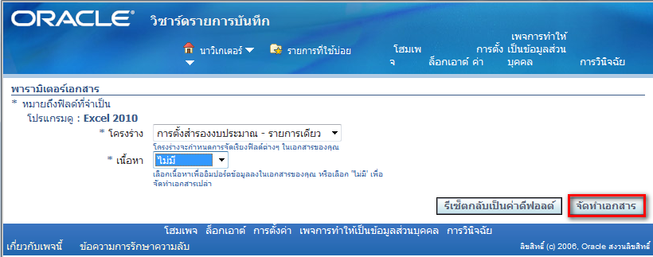

-Popup will show in Browser click ‘Open’
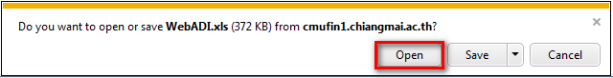

-Program excel will open up Manu Security warning click ‘Enable Content’
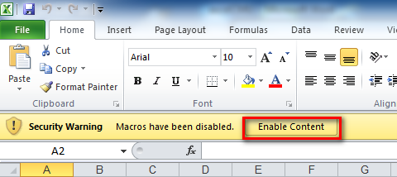

-Finish
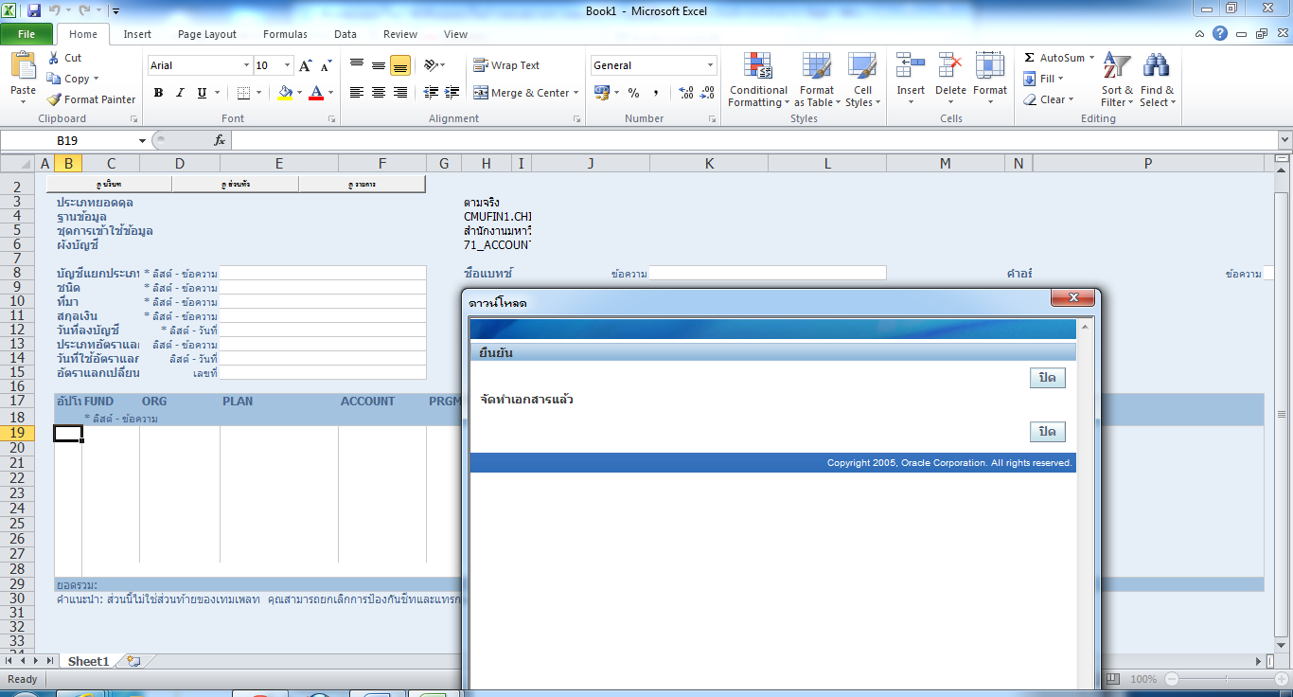

4. Test Export file [excel, word, pdf] from browser ie/Firefox
-Go to Manu ‘Payables71’ click ‘ตรวจสอบเงินทุนคงเหลือ’
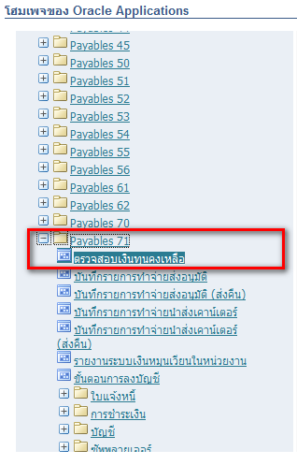
Install Java [Use cases for the first time]
-Popup will show in browser click ‘install This Add-on for All users on This Computer….’

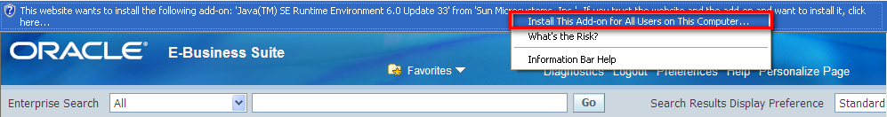

-will have Dialog blog show click ‘install’ [button]
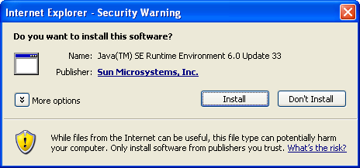

-click install>
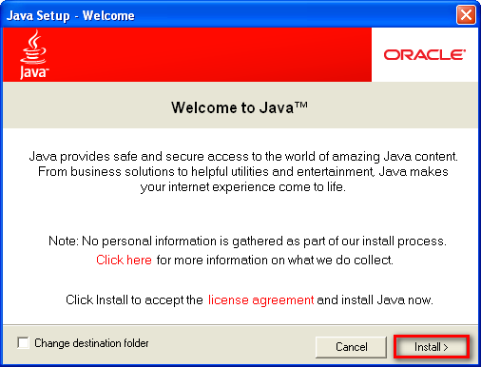
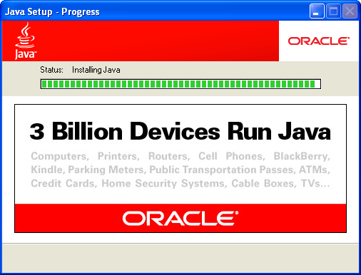
-click Close
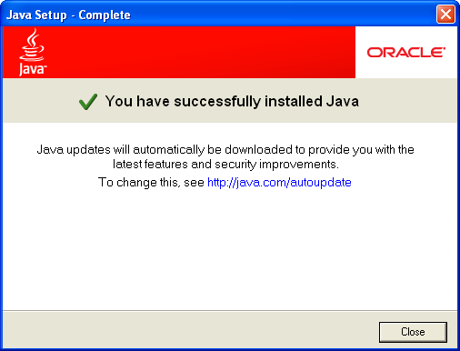
-Go to Manu ‘Payables71’ click ‘ตรวจสอบเงินทุนคงเหลือ’ again
-Check ‘Always trust content from this publisher ‘ and click Run
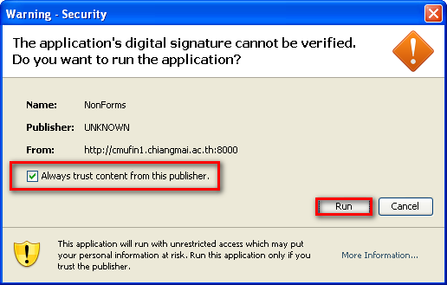

-Will show is picture
-click menu ‘Other->Requests->Run and select ‘Single Request’ ->Ok
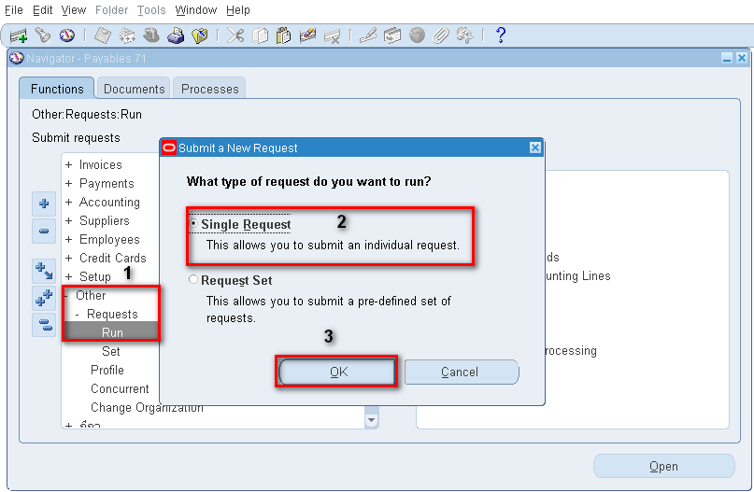
Ex
-Search file xml in channel Name and select name ‘Unaccounted Transactions Report (XML) and click OK
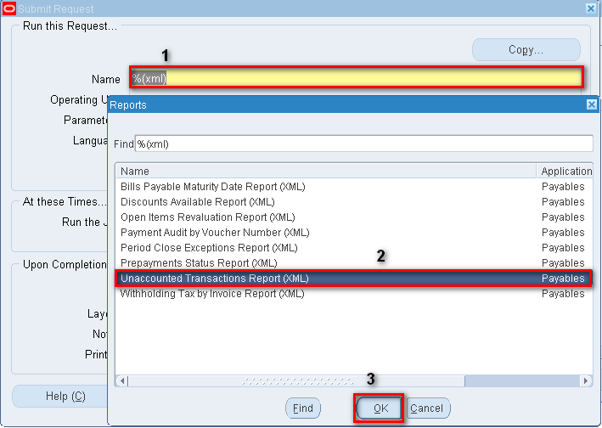
-Select Period Name: May 2555 and click Ok
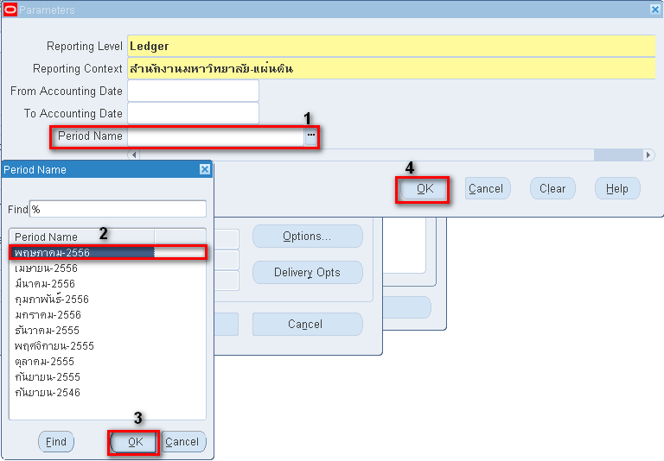

-and Submit report
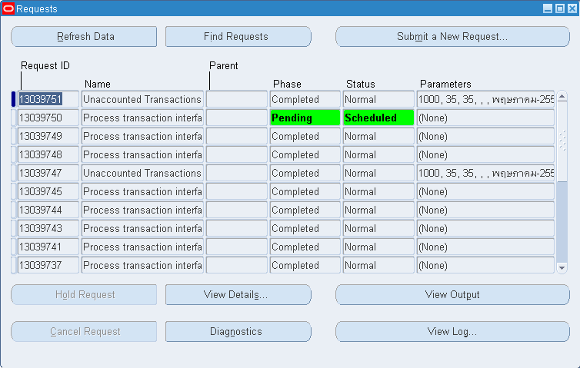
-View Output is Show as picture is file type Word click Open
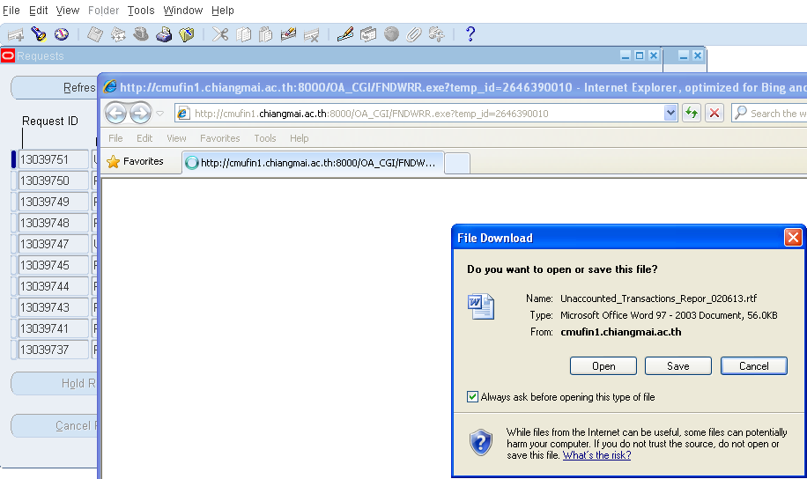
-Submit a New Request select file type at Manu option select format file is Excel and submit again
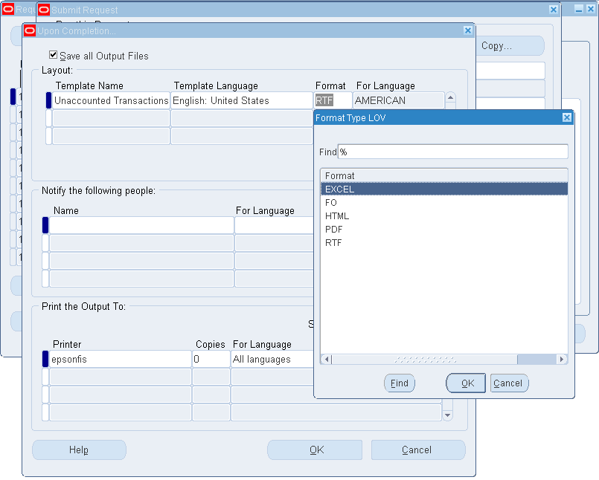

-Show is Picture
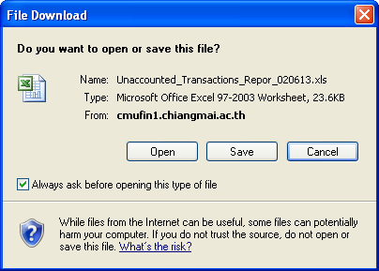
-Submit a New Request select file type at Manu option select format file is PDF and submit again

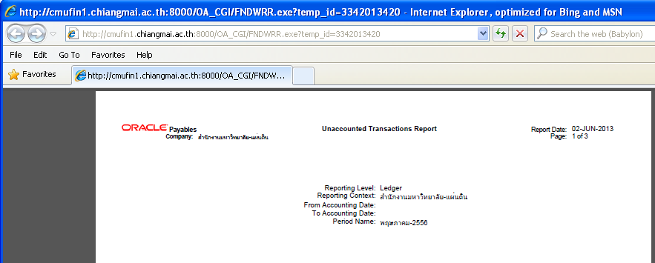
-Completed

